Enhancement One Narrative: Software Engineering & Design
Dylan Kimball
CS-499
Brooke Goggin

Artifact Overview
The artifact I chose to enhance for category one, Software Engineering & Design is my final project from CS-330 - Computational Graphics and Visualization. This project was created in October of 2023 in Visual Studio. The program is made with C++ and utilizes OpenGL to create a graphics engine that renders 3D objects and creates a scene that the user can move through. The scene rendered through this program is a image of my desk containing two monitors, a baseball, water bottle, and stuffed animal tarantula (See figure 1 below).
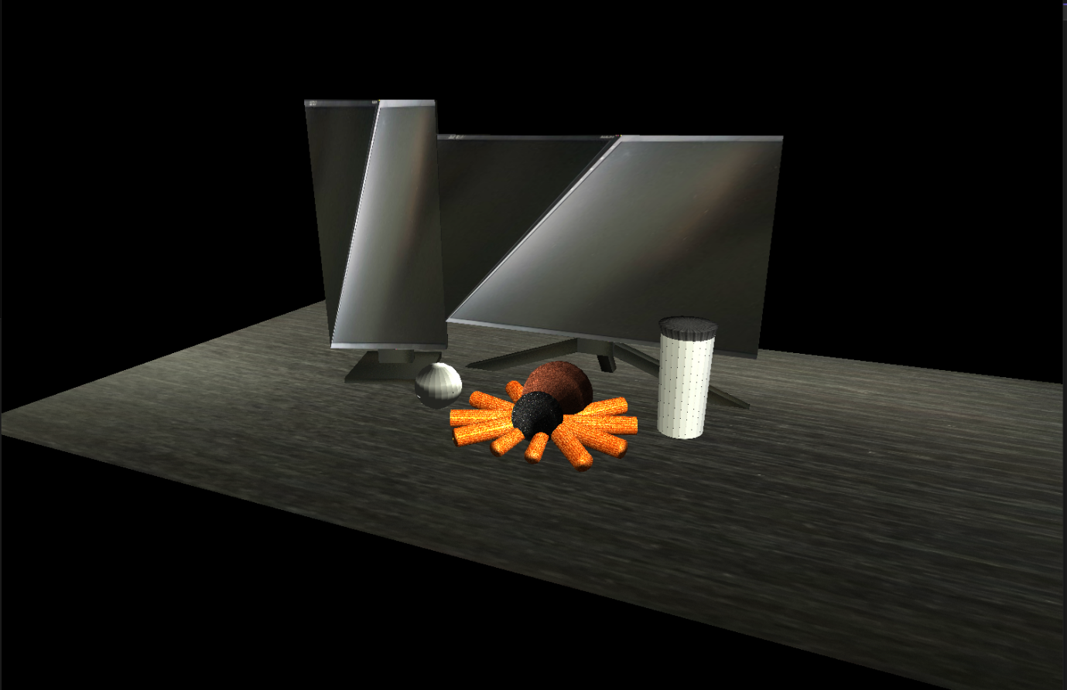
Figure 1 (Image of rendered scene)
The reason that this artifact is included in my ePortfolio is because it showcases my coding abilities with the C++ language. C++ is the language I am most comfortable with and know the most in, so I wanted to provide a project that really displays my capabilities with C++. The program is complex and large which in turn required multiple different coding techniques to be used, such as reusable functions to draw multiple objects, loops to handle rendering, handling user inputs through key-binds, and performing algebraic equations. The four drawing functions that handle drawing different shapes all allow for a variety of customization in how to object is drawn. Due to the way these functions are set up, multiple types of objects can be rendered through the use of only these four functions instead of needing a new function for each object in the scene. The project and the enhancement made to it showcases my skills when it comes to creating well formatted, readable, and functional code. This project also displays my ability to find faults or inefficiencies in a project and come up with and implement innovative or effective solutions.
Enhancements
The artifact was enhanced by increasing the complexity of the program and making parts more efficient. Starting with efficiency, the ten legs of the tarantula were originally drawn through ten separate calls. This was improved by reworking the CylinderSphere drawing function to allow for one call of the function to be made and have a loop activate which would draw all legs of the tarantula. This function also does get used by other objects, so in order to make this work for a multi object and single object drawing call, the function will first perform a check to see if it will be drawing multiple objects or not. Moving on to the complexity, the first enhancements made was to allow the user to manipulate the lights in the scene. The user can freely move both lights anywhere in the scene or position it at the current camera position allowing for the entire scene to be viewed. Lastly, animation was added to the baseball and tarantula. The baseball slowly increase in size and jump forwards and backwards across the desk while the tarantula will slowly stand up and lay back down.
Course Objectives
I set out to meet two course objectives with this finished enhancement and I have met these objects. Below is first objective that I have met through this enhancement:
- Design and evaluate computing solutions that solve a given problem using algorithmic principles and computer science practices and standards appropriate to its solution while managing the trade-offs involved in design choices.
My enhancement contained a few functions to handle real time animation for the ball and the tarantula. The finish product also give the user the ability to manipulate the lighting by moving it around the scene or setting it to orbit the scene. All these functions required some calculations to be performed to cause the movement, stop the movement when needed, or reverse the movement. This can also be seen with my rework of the sphere / cylinder drawing function to draw each tarantula leg and updating values to the draw the next leg in the correct position right after. The second course objective I’ve met is the following:
- Demonstrate an ability to use well-founded and innovative techniques, skills, and tools in computing practices for the purpose of implementing computer solutions that deliver value and accomplish industry-specific goals.
I met this objective through my rework of the sphere / cylinder drawing function as well as the code I created to handle real time animation. When creating these features I used simple but effective techniques to ensure good functionality while not being needlessly complex or large. One problem that presented itself in my original program was the inefficiency how the tarantula legs were being drawn. Each leg was the same with just a different rotation, so it didn’t make much sense to have a separate call passing separate data for each leg. I rewrote the program to keep the original functionality while also adding the ability to draw multiple objects with just one call using that same function.
Reflection and Challenges
Working on this project again and implementing these enhancements allowed me to learn a lot about how I’ve improved and more about how I can strive to improve my projects. Starting out I really had to re-educate myself on this project and OpenGL works as had forgotten. This is where I was very thankful for my previous comments as they were very descriptive in each step of the code. I also learned in this step how much my formatting needed improvement. I missed this in the code review, but doing an even deeper dive showed me many areas that were lacking and that I needed to improve on. After I had re-formatted the code I started on the enhancements. When working on the tarantula leg drawing function I faced a few challenges is getting the legs to be properly positioned and getting the function to work with the other objects being drawn. I went through a trial and error process until I slowly figured out what I was doing wrong. After this I was able to push through and create the function which helped me learn just how much you can do with a function to make to reusable and save some space and processing power. Creating the remaining enhancements relating to animation and light manipulation were actually much easier than I had anticipated them to be with the exception of the light that orbits the scene. Due to my previous challenges I had already become accustom to utilizing basic openGL transforms which is essentially all the animations needed to do. I was able to implement a few restrictions to ensure that the animation follows a specific pattern, however this part went smoothly.
The main challenge I am facing has to do with the orbiting light. This feature is much more challenging that I had previously thought, and I have gone through multiple iterations of a function to attempt this, however none have worked. Although it is frustrating, I have been able to learn so much more about openGL and what I can really do through the research I have done. Overall I learned a lot about how I’ve improved in my coding standards, and about open GL and its many functions.

